Project Design Phase
Solution Architecture
Date | 14/7/2026
Team ID | SWTID-2026-1032
Project Name | EduGenie – Google Gemini Powered Learning Assistant
Maximum Marks

Solution Architecture
The EduGenie Learning Assistant follows a modular AI-powered solution architecture that integrates a responsive web interface, FastAPI backend, Generative AI models, and a database to deliver intelligent educational assistance. The architecture bridges user interactions with AI-powered processing, ensuring scalability, maintainability, and efficient response generation.
The primary goals of the solution architecture are to:
- Provide an intelligent AI-powered educational platform for students, educators, and self-learners.
- Establish seamless communication between the frontend, backend, AI models, and database.
- Ensure modular development for easy maintenance, testing, and future enhancements.
- Deliver fast, accurate, and personalized educational responses using Generative AI.
- Support scalable deployment with cloud-ready architecture and RESTful APIs.

Solution Architecture Diagram
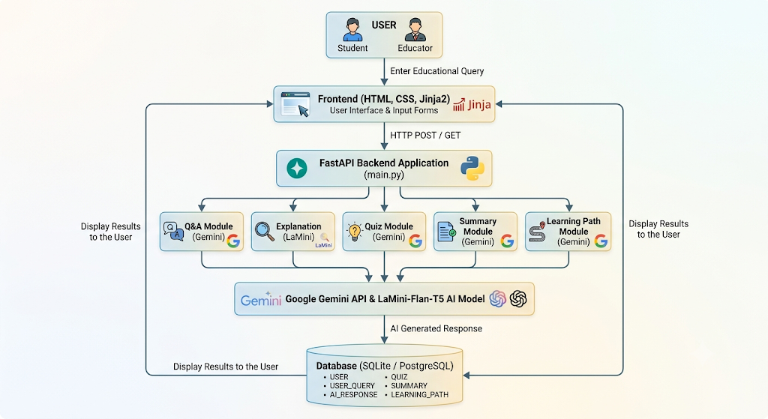

Architecture Components
1. User Layer
The user interacts with the EduGenie Learning Assistant through a web browser. Users can ask academic questions, request concept explanations, generate quizzes, summarize educational content, or obtain personalized learning recommendations.
2. Presentation Layer
The frontend is developed using HTML, CSS, and Jinja2 templates. It provides a responsive and user-friendly interface with forms for each educational feature. User requests are sent to the backend through HTTP requests.
3. Application Layer
The backend is implemented using FastAPI, which manages API routing, request validation, AI module invocation, and response generation. It exposes RESTful endpoints such as:
- /qa
- /explain
- /quiz
- /summarize
- /learn/recommendations
4. AI Processing Layer
EduGenie integrates two AI models:
- Google Gemini 1.5 Pro for Question Answering, Quiz Generation, Summarization, and Personalized Learning Recommendations.
- LaMini-Flan-T5-783M for lightweight Concept Explanation, providing concise and beginner-friendly explanations.
These models process user queries and generate intelligent educational responses.
5. Data Layer
The database stores application data using relational tables, including:
- USER
- USER_QUERY
- AI_RESPONSE
- QUIZ
- SUMMARY
- LEARNING_PATH
Primary and foreign key relationships maintain data integrity and enable efficient retrieval of educational information.

Workflow of the Solution
- The user opens the EduGenie web application.
- The user selects an educational feature and enters the required input.
- The frontend sends the request to the corresponding FastAPI endpoint.
- FastAPI validates the request and forwards it to the appropriate AI module.
- Google Gemini 1.5 Pro or LaMini-Flan-T5 processes the request.
- The AI-generated response is returned to the backend.
- The response is stored in the database for future reference.
- The processed output is displayed instantly on the frontend.

Advantages of the Solution Architecture
- Modular architecture improves maintainability and scalability.
- FastAPI enables high-performance REST API communication.
- Google Gemini provides advanced reasoning and educational content generation.
- LaMini-Flan-T5 offers efficient local inference for concept explanations.
- The responsive frontend ensures an intuitive learning experience.
- Database integration enables organized storage of users, queries, and AI-generated content.
- The architecture supports future enhancements such as multilingual support, voice interaction, mobile applications, LMS integration, and AI-powered learning analytics.

Conclusion
The EduGenie Learning Assistant Solution Architecture provides a scalable, modular, and AI-driven framework for delivering intelligent educational assistance. By integrating a responsive frontend, FastAPI backend, Google Gemini 1.5 Pro, LaMini-Flan-T5, and a relational database, the system efficiently supports question answering, concept explanation, quiz generation, text summarization, and personalized learning recommendations. The architecture ensures high performance, maintainability, and flexibility, making EduGenie suitable for both current educational needs and future AI-powered enhancements.

